# DAILY ASSESSMENT

|  |  |  |  |
| --- | --- | --- | --- |
| Date: | 3/07/2020 | Name: | Chesmi B R |
| Course: | **IIRS** | USN: | 4AL16EC100 |
| Topic: | **Photogrammetric products from satellite stereo images** | Semester & Section: | 8TH SEM & A Section |
| Github Repository: | chesmibr |  |  |



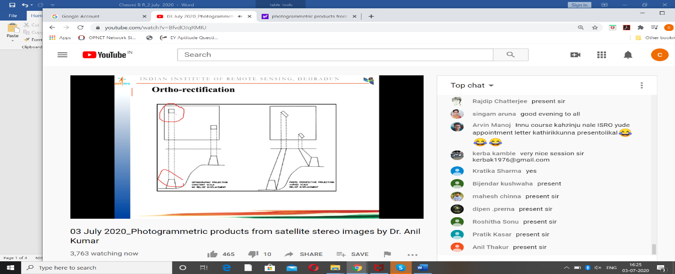

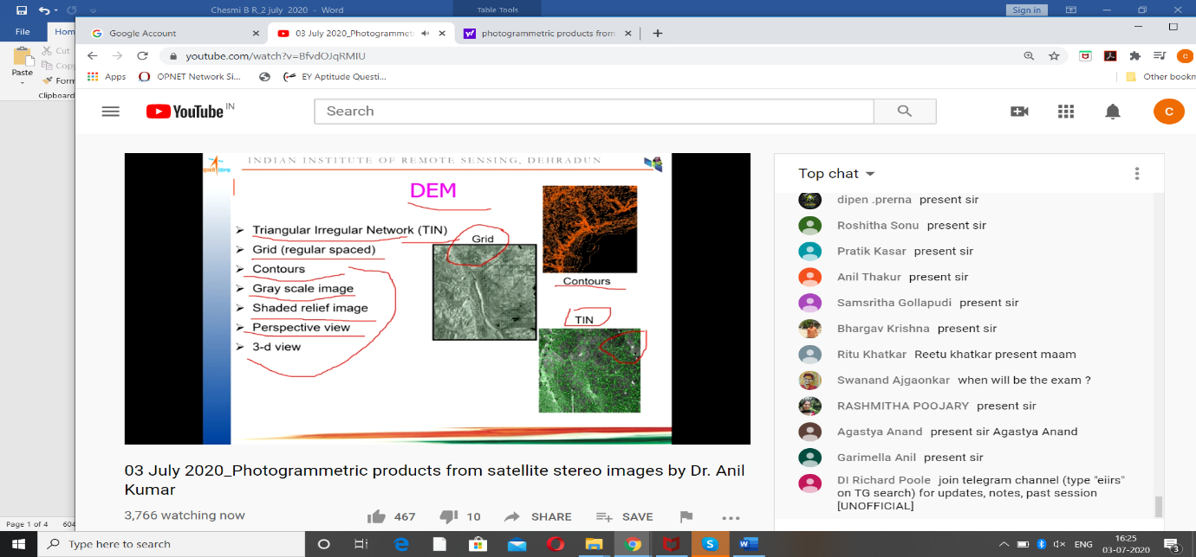

Stereoscopic imagery collection mode refers to when the satellite sensor acquires two images of the same location taken from different angles.

In the case of DigitalGlobe’s stereoscopic imagery, the images are taken by the same satellite about 45-90 seconds apart.

The satellite takes a shot of the location of interest, then continues traveling along its orbit for a short time, then rotates the camera to point back towards the same location to collect the second image. This is called in-track stereo.

A stereoscopic pair can also be acquired in cross-track stereo mode when the satellite completes at least one orbit between the two image collections.

In-track stereo is more valuable because less will have changed in the target location between the two shots.

All DigitalGlobe satellites can collect imagery in stereoscopic mode. However, due to sensor model uncertainty, the best DEMs are created (more on this later) from stereoscopic imagery collected by WorldView-1, WorldView-2, and WorldView-3.

Using photogrammetric techniques, a pair of imagery shots collected in stereo mode can produce a 3D elevation model of the area.

Digital Elevation Model (DEM) extraction algorithms first perform a method of image matching on the two images in the stereoscopic pair to identify homologous features in both images.

Instead of matching just a few distinctive features, the algorithms attempt to match each pixel with its corresponding pixel from the other image. Because of the slightly different collection geometry and the resulting distortion, any two homologous points on a pair of images will be in slightly different places.

The DEM extraction algorithms use the disparity between the two point locations in combination with the image collection geometry to determine the exact distance from that point to the satellite.

Because the position of the satellite is also precisely known, the the algorithm can calculate the point’s exact horizontal (x,y) and vertical (z) location.

This process of converting matched pixels into geographic coordinates is then calculated over the entire extent of the image pair.

Next, the algorithm interpolates a surface to match the point cloud (collection of matched points), divides the resulting surface into an regularly spaced grid, and writes the output as a raster (gridded) DEM.

The resulting DEM is referred to as a stereo-derived elevation model.

## PGC Elevation Model

PGC provides stereo-derived elevation models products at 2 meters per pixel resolution or a reduced 8 meter resolution.

#### Strip Elevation Models

The most common product is the DEM strip, which is the result of running elevation extraction on a set of images all taken in sequence. The strips are 15-17 km wide and 15-100 km long (i.e. the same extent as the source imagery pairs).

A key attribute of the strips is that they have a specific timestamp. Their source images were all collected within a short period, and the strip DEM reflects the state of the terrain at that time.

Another strip DEM taken a year later over the same location would show if there had been any significant elevation changes in the area in the intervening time.

#### Mosaic Elevation Models

PGC also releases mosaics of the DEM strips. These products cover a larger area, but no longer preserve the unique timestamped nature of the strips.

A mosaic might be made from source DEMs spanning five years, for example.

In order to avoid abrupt discontinuities in elevation values, the source DEMs are co-registered and the edges are blended to create the effect of a single, continuous elevation model.

## Work in your desired environment

The ArcGIS suite of photogrammetric tools are designed to process drone, aerial, or satellite imagery to match your work environment scenario. If your project is small, use ArcGIS Pro and the orthomapping tools right on your desktop. Scale to use distributed processing and storage when you need extra computation power to create orthomosaics and terrain models over large areas or when working with millions of high-resolution images.

## stereo feature collection

Imagery is the source of most high-accuracy basemaps. The ArcGIS Pro stereo display and measurement tools help you turn your imagery into an authoritative 3D model of your environment. Accurately interpret and extract features to create topographic maps for planning and analysis applications.